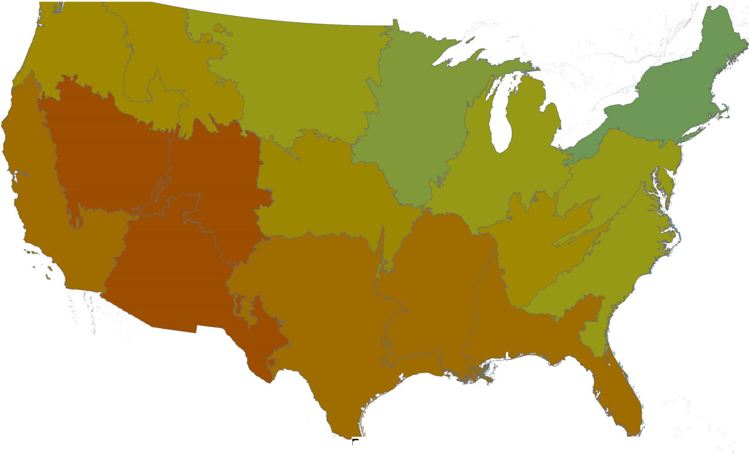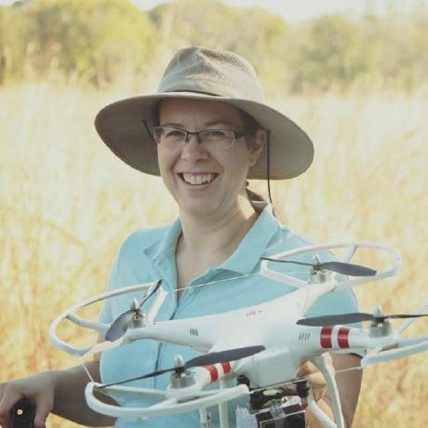

Patterns of soil organic
carbon deficit in the Conterminous US

Terry Loecke, PhD Skye Wills, PhD 12 Dec 2018

Land use, climate, or management change
Soil organic C (g C g dry soil-1)

e.g., Paustian et al., 2000

Time (scale system dependent)

heterogeneous
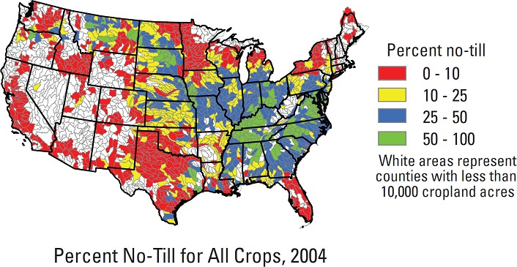
https://water.usgs.gov/nawqa/home_maps/tillage.html

Land use, climate, or management change
Soil organic C (g C g dry soil-1)

Time (scale system dependent)

Assessment (RaCA)
- Provide a traceable probabilistic estimate of CONUS SOC content and stocks at a single point in time .
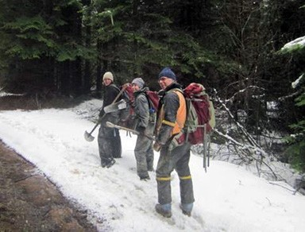
- Better understanding of land use and landscape level patterns of SOC.

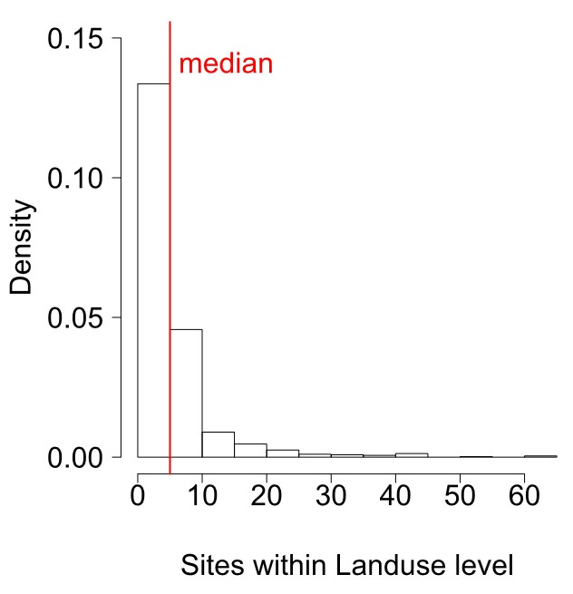
methodology
Stratified random sampling design 17 Regions
8-20 soil groups – Wills et al, 2013
6 Land uses – correspond NRI, NLCD
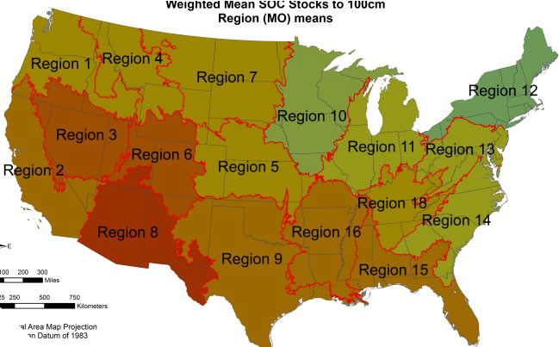1 to 61 sites (median = 5) - randomized Five (>1m deep) pedons per site
sectioned by genetic horizon

• 144,833 samples collected
• Field described soil horizons, texture
• Air-dried, sieved, VNIR scans to predict SOC, TN, TS (Wijewardane et al., 2016)
• All O horizon and central pedon samples analyzed for C,N, and S on elemental analyzer (~50k)
• 32,084 pedons to at least 1 m of depth or rock layer
• 6017 sites
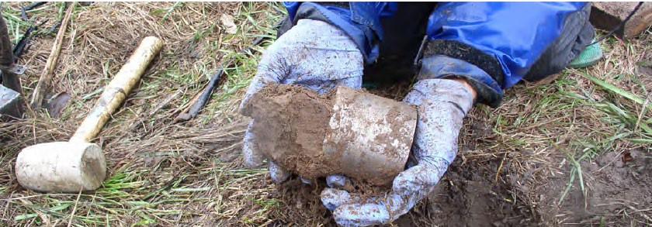
• Bulk density – 0 to 50cm and modeled below (Sequeria et al., 2014)
• > 300 soil scientists

Land use, climate, or management change
Soil organic C (g C g dry soil-1)

Δ native

Time (scale system dependent)

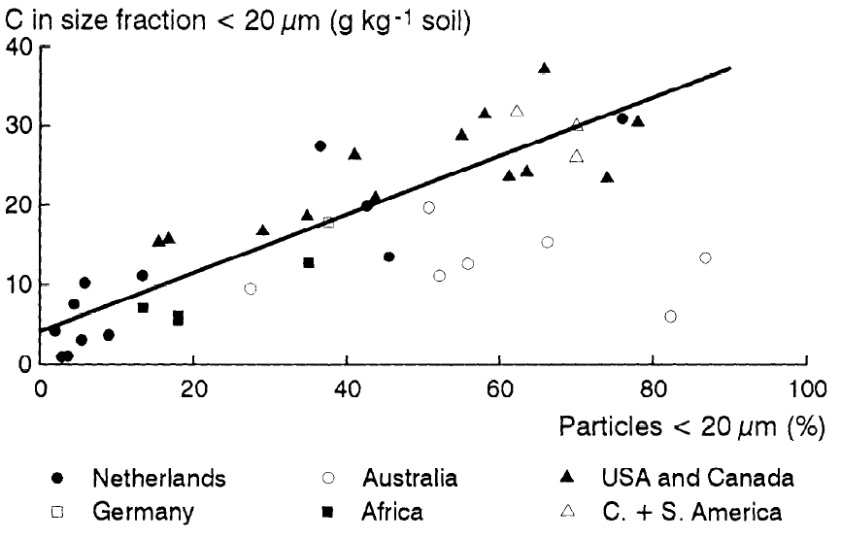SOC (g kg-1) = 4.1 + 0.37*%
Soil carbon saturation: concept, evidence
and evaluation

J. Hassink, “The capacity of soils to preserve organic C and N by their association with clay and silt particles,” Plant Soil, vol. 191, pp. 77–87, 1997.

Land use, climate, or management change
Soil organic C (g C g dry soil-1)

Δ native
(0-100%)

δ MA (>100%)

Mineral Associated SOC
δ MA (0-100%)

Time (scale system dependent)

Δ Native
(0-5 cm)
0
0 -

0
co
"O
Q)
r.o... 0

ro
_j_ l l

'
'
'

::::l (0
(I)
g
B
(_)
0
(I)

0
0
-st-

0
' '
'
B
N

l 0 -
I I I I

40 -
m
100

75

50

2.5

35 -
0
% Saturated

30 -

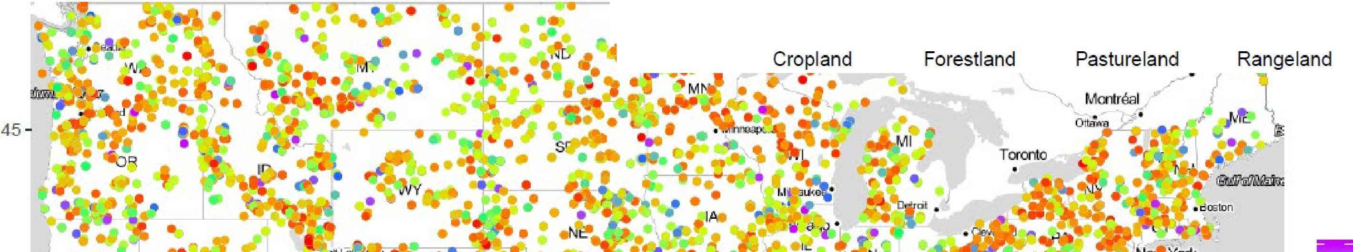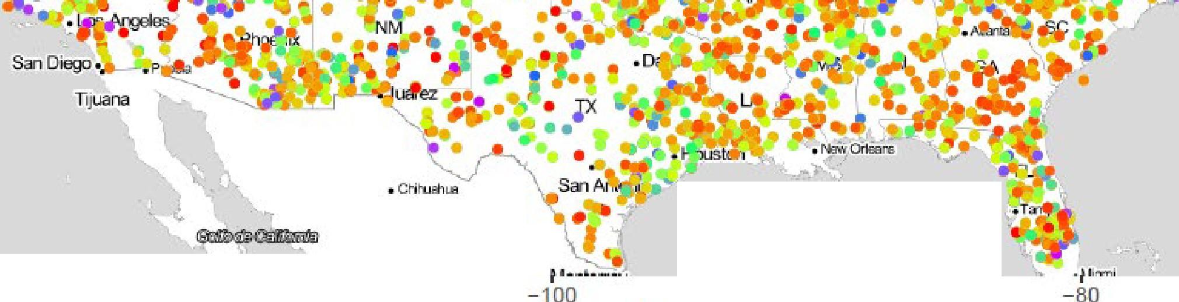

I
-120

I
- 110

Ion

I
-90

I
-70

Δ Native saturation similar among
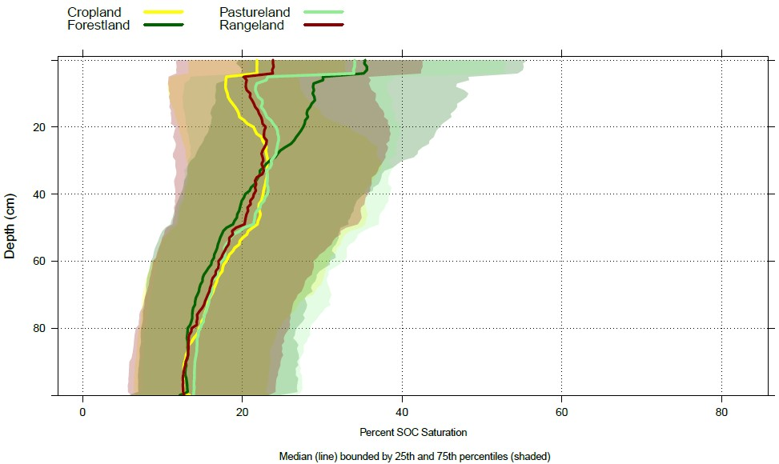
Land uses at depth

δ MA SOC
saturation of 0-5 cm
79% have less SOC than mineral associated model

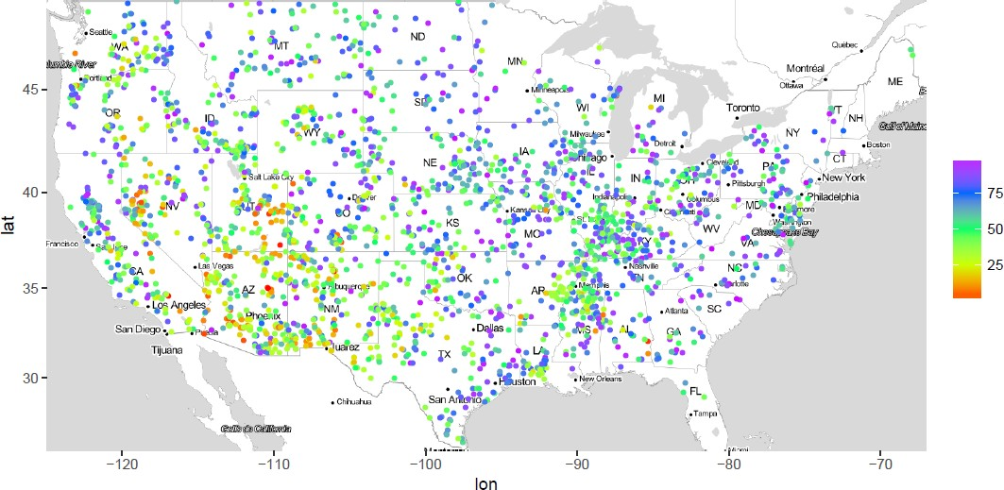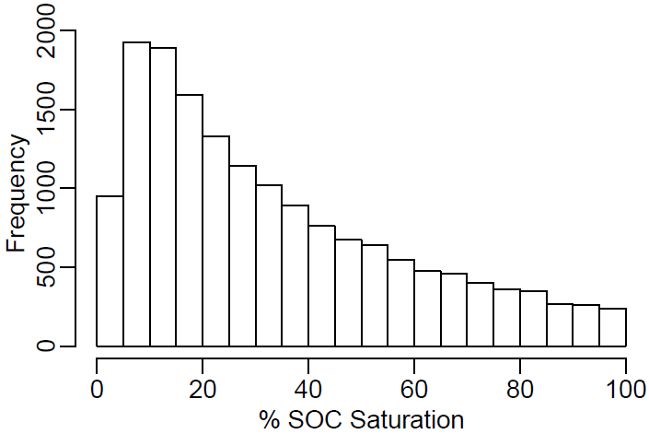

% Saturated

SOC deficit (saturated and unsat)

100
% variance explained

80

60

40

20

0
SOC SOC saturation SOC unsaturated
intersite Land use Soil group Region

variation in the SOC unsaturated

100
% variance explained

80

60

40

20

0
SOC SOC saturation SOC unsaturated
intersite Land use Soil group Region

Sink SOC potential by Land Use

Depth | LU | km2 | SOC PgC | δ MA (Pg C) | Δnative (Pg C)
5 cm | Cropland | 1235982 | 1.4 | 0.5 | 1.1
 | Forest | 1608849 | 5.6 | 0.4 | 3.9
 | Pasture | 526025 | 1.0 | 0.3 | 0.7
 | Rangeland | 2269444 | 2.1 | 1.1 | 1.7
30 cm | Cropland | 1235982 | 6.6 |  | 5.1
 | Forest | 1608849 | 13.5 |  | 9.4
 | Pasture | 526025 | 3.1 |  | 2.2
 | Rangeland | 2269444 | 7.7 |  | 5.7

- RaCA database provides a wide scale snapshot of CONUS SOC to 1m of depth
  - Google it!
- Potential SOC sink in 0-5 cm of CONUS
  - 2.3 to 7.4 PgC
  - ~ 23% to 75% increase over current SOC pool
- Need to develop better generally applicable proxies for lower bounds of SOC sink
- All land uses in CONUS are potential sink!

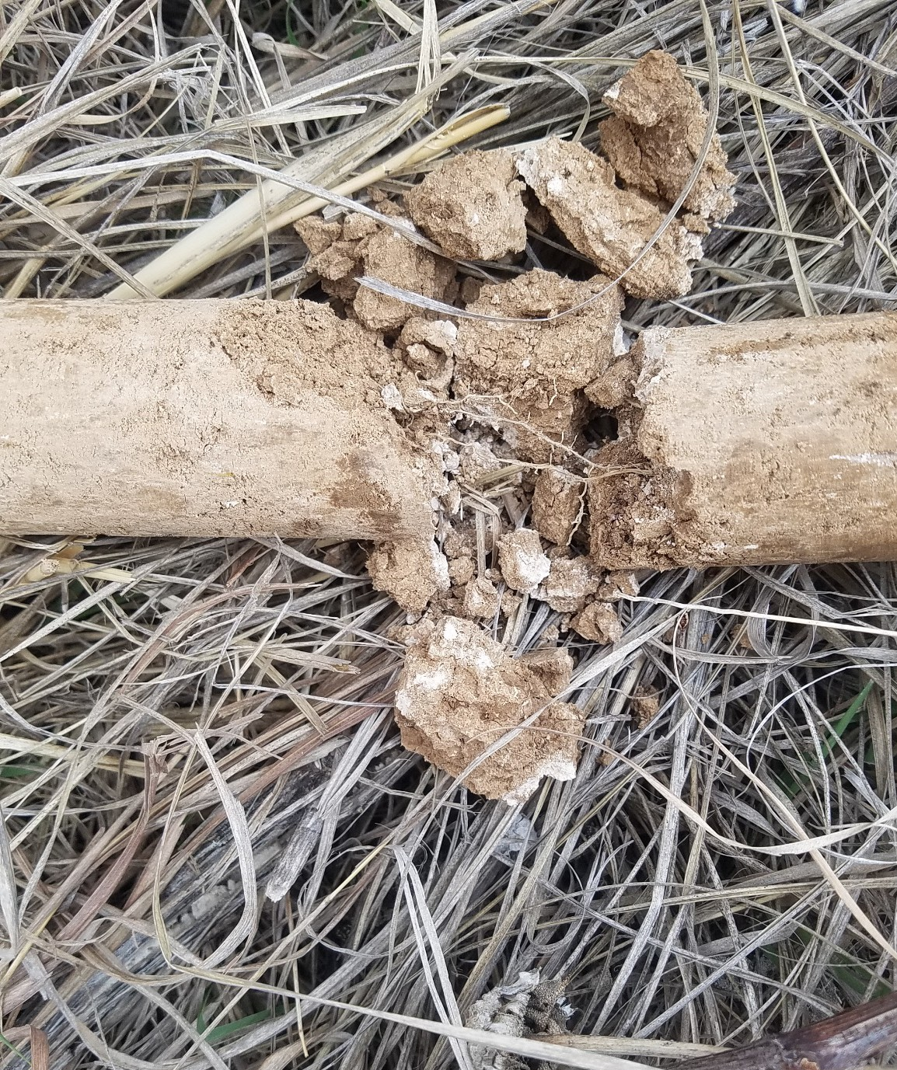

LOECKE.TERRY@ku.edu

Your abstract has been submitted for the 2018 AGU Fall Meeting. You will receive an email confirmation.

Click HERE to print this page now.

This page indicates that you have completed your abstract submission and an email confirmation will be sent to you.
If you do not receive an email confirmation, please contact agu@confex.com to ensure your abstract was submitted and to have a confirmation email sent to you.
This confirmation does not guarantee that your abstract was accepted and only confirms that your abstract will be submitted for consideration by the Program Committee.
In this system, there is no 'Draft' option. Once the abstract is submitted, you may review, edit or withdraw your abstract until the deadline of 1 August 2018 23:59 EDT/03:59 +1 GMT.

Do not withdraw a paid abstract submission if edits are needed or to begin a new submission. You may make any edits to your abstract until the submission deadline.
Abstract fees are nonrefundable.
Once submitted, your abstract will need to be withdrawn if you no longer wish to have it considered by the Program Committee.
Consider making your submission citable and more discoverable by adding it to the Earth and Space Science Open Archive (ESSOAr). ESSOAr is free to post and view content. Please read our submission guide and FAQ for more information.

Patterns in soil organic carbon deficit across the Conterminous US

Terry Loecke, University of Kansas, Lawrence, KS, United States and Skye A. Wills, USDA NRCS National Soil Survey Center, Lincoln, NE, United States

Abstract Text:

Soil organic carbon (SOC) is integral to ecosystem stability, agricultural productivity, and climate regulation. The capacity of soils to stabilize additional SOC is highly uncertain, yet critical to understanding terrestrial ecosystem feedbacks to rising atmospheric carbon dioxide. Conceptually, the difference between a soil's capacity to sequester SOC (i.e., SOC saturation) and the current stock of SOC is the SOC deficit. To explore patterns in SOC deficit, we are using the newly collected, Rapid soil Carbon Assessment project (RaCA) database. The RaCA database contains more than 6000 pedons from the Conterminous US collected to 1 m of depth or more. Data for these pedons include SOC, soil inorganic C, total soil nitrogen, texture class, VNIR spectrum, and more, all of which are traceable and publically available from the USDA Natural Resources Conservation Service. The general goal of this paper is to test hypotheses about the roles of soil depth, land use and land cover, landscape position, and ecosystem type play in maximizing SOC content. We use existing methods to determine SOC saturation as related to soil texture classes, soil surface area, and statistical approaches. One specific goal is to determine the probability of SOC deficit in sequential soil horizons. For example, we test if SOC saturation is related to the saturation of proximal soil horizons and then explore land use and spatial patterns in the probability that SOC saturation is related to proximity.
Understanding patterns in SOC deficit may be valuable to modelling terrestrial C dynamics in the Anthropocene.

Session Selection:
Soil organic carbon: mechanisms of stabilization and change in the Anthropocene

Submitter's E-mail Address:
loeckete@ku.edu

Abstract Title:
Patterns in soil organic carbon deficit across the Conterminous US

Requested Presentation Type:
Assigned by Program Committee (oral or Poster)

Previously Published?:
No

AGU On-Demand:

https://agu.confex.com/agu/fm18/b/papers/index.cgi?username=456308&password=*cookie 1/2

Yes

Abstract Payment:
Paid (agu-fm18-456308-7885-5397-1653-0722)

For non-students only: I would like to volunteer as an OSPA judge.

For non-students only: I am willing to help find OSPA judges for students in my session.

First Presenting Author
Presenting Author
Terry Loecke

Primary Email: loeckete@ku.edu

Affiliation(s):

University of Kansas Lawrence KS (United States)

Second Author Skye A. Wills
Primary Email: skye.wills@lin.usda.gov

Affiliation(s):

USDA NRCS National Soil Survey Center Lincoln NE (United States)

If necessary, you can make changes to your abstract submission

You may access your submission to make any edits or submit another abstract by clicking here. Your Abstract ID# is: 456308.
Any changes that you make will be reflected instantly in what is seen by the reviewers.
After the abstract proposal is submitted, you are not required to go through all submission steps to make edits. For example, click the "Authors" step in the Abstract Submission Control Panel to edit the Authors and then click save or submit.
When you have completed your submission, you may close this browser window or submit another abstract Abstract Viewer.
Tell us what you think of the abstract submission process

https://agu.confex.com/agu/fm18/b/papers/index.cgi?username=456308&password=*cookie 2/2

