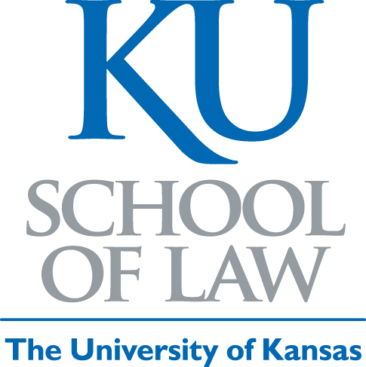

Corporate Governance as Risk Regulation in China: A Comparative View of Risk Oversight, Risk Management, and Accountability

Virginia E. Harper Ho
Professor of Law
University of Kansas School of Law
Lawrence, KS 66045

University of Kansas School of Law Working Paper
2012

This paper can be downloaded without charge from the
Social Sciences Research Network Electronic Paper Collection
Citation:
Harper Ho, Virginia E., Corporate Governance as Risk Regulation in China: A Comparative View of Risk Oversight, Risk Management, and Accountability (August 28, 2012). University of Kansas School of Law Working Paper, August 28, 2012.

Other Sources:
http://ssrn.com/abstract=2137715

Key words:
corporate governance, risk management, ERM, China, Europe, internal controls, stakeholders, corporate social responsibility

Abstract:
Risk management and oversight have long been recognized as core corporate governance issues and have gained renewed attention in the wake of the financial crisis. Following global trends, recent corporate governance reforms in China also focus on risk oversight and risk management. This article is the first to examine the intersections between corporate governance and risk regulation in China from a comparative perspective. It surveys corporate governance tools that have been adopted by Chinese regulators and firms to motivate effective risk oversight and risk management across the corporate enterprise, focusing on China’s regulation of internal controls and risk management systems. These internal mechanisms are particularly important given the widely recognized limits of external monitoring and enforcement mechanisms within China.
This article observes that recent guidelines on enterprise risk management (ERM) and internal controls reflect international corporate governance standards, and that China adopts a broad perspective on risk oversight that extends to both financial and non-financial risks. China’s adoption of international models offers a new opportunity to reexamine long-standing debates on the potential for global corporate governance convergence. This article argues that China has adopted a regulatory approach to internal risk oversight and management that is consistent with its historical law reform trajectory, the reality of China’s state-dominated equity markets, and the continued influence of the state on firm management. Its conclusions support the literature on the path dependency of corporate governance systems and prior comparative studies of corporate governance in China that find convergence of form but divergence of function.

